Pack 116 Cub Scouts
Foxborough , Massachusetts
Seven Rivers District
Old Colony Council
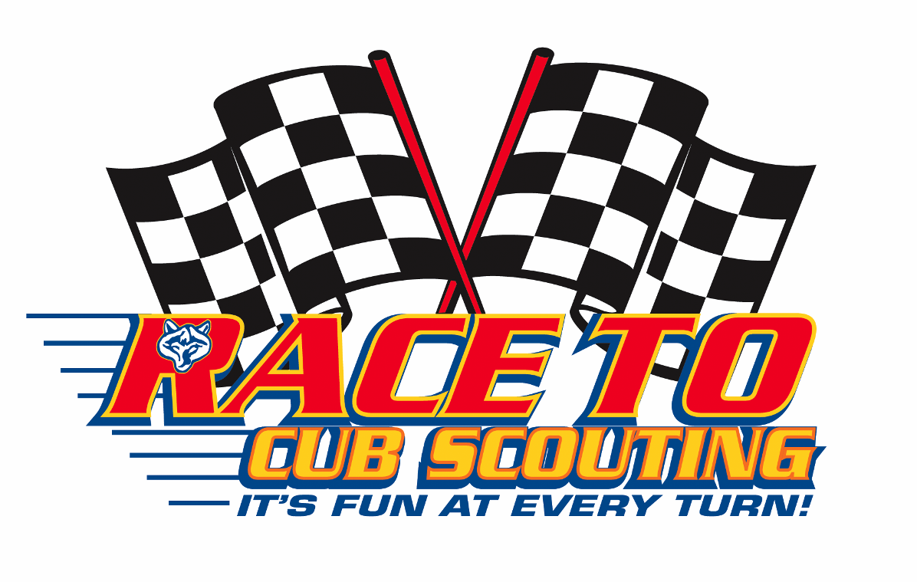
Pinewood Derby
RULES, REGULATIONS, PROCEDURES,
AND MORE…
IF you have Fun and help others to have Fun,
then we are all WINNERS!
Revision 4.0
Change Record

REVISION | DATE | SUMMARY OF CHANGE | AFFECTED PAGES
1.0 | 11/19/2006 | INITIAL RELEASE | ALL
2.0 | 11/18/2007 | Editorial corrections, Updated start gate & finish line sections with new equipment. Modified attendance requirements. Modified car staging by scouts. Added “ignoring each racer's worst time”. Max height changed to 3” from 4”. | ALL
3.0 | 11/16/2008 | Minor editorial corrections, changed speed awards from Top 3 to 10 | 13
4.0 | 11/15/09 | Minor editorial corrections. 3.4 Attendance modified . “Although a scout’s car may be allowed to race if he has been granted an exception, the car will not be allowed to advance to the Grand Finals.” Special Guests allowed to race if approved by commissioner. The Cub Master is allowed to race a car in the Scout Race (Cub Master’s Pace Car) and the Sibling & Adults race. | 3, 4
WARNING!!!!
THIS DOCUMENT IS SUBJECT TO CHANGE OFTEN AS WE ADD ADDITIONAL TIPS, HINTS, AND INFORMATION.
CHECK BACK FOR UPDATES OFTEN!
Questions concerning this document should be addressed to the
Pinewood Derby Race Commissioner, please refer to Section 9 APPENDIX B: The Race Committee, Volunteers, & Officials for a list of the current officials and contact information.
Parent Participation and Safety
Parents are encouraged to teach new skills and principles as the scouts build their cars. The Scout should do as much as he can by himself, try not to be too critical or expect perfection. Any technical assistance given by an adult should be fully explained to the Scout so that he may use the knowledge on future projects. Above all else, participating in the Pinewood Derby should be safe and fun. Power tools, sharp hand tools, paints, glues, and other potentially dangerous items must only be used under the careful and strict supervision of a knowledgeable adult. Under no circumstances must parents work on a Pinewood Derby race car when the Scout is not present.
Table of Contents
1 PURPOSE 1
2 SCOPE 2
3 GENERAL RULES & REGULATIONS 2
3.1 Qualification to Race 2
3.2 Essential Materials 2
3.3 Competitor Categories 3
3.4 Attendance 3
3.5 New Work 3
3.6 Drivers Licensing, Car Registration and Inspection Date(s) and Time(s) 3
3.7 Late Registration and Inspection 4
3.8 Failure to Pass Inspection 4
3.9 Impound 4
3.10 Car Design Rules Interpretation 4
3.11 Race-Day Rules Interpretation 4
4 CUB SCOUT RACE CAR DESIGN REGULATIONS 5
4.1 Overall Car Specifications 5
4.2 Material 6
4.3 Weight 6
4.4 Wheels and Axles 7
4.5 Size 7
4.6 Lubricants 8
4.7 Unacceptable Construction 8
4.8 Gravity Powered 8
5 THE RACING ENVIRONMENT 9
5.1 Track Length and Drop 9
5.2 Track Curve 9
5.3 Lanes 9
5.4 Finish Line Sensor Location 10
5.5 Finish Line Judging 11
5.6 Car Brakes 11
6 RACE DAY RULES, REGULATIONS, AND INFORMATION 11
6.1 Inspection Gages 11
6.2 Race Day Lubrication 11
6.3 Car Handling Responsibility 12
6.4 Lane Assignment 12
6.5 Car Leaves Lane 12
6.6 Car Leaves Track 12
6.7 Car Repair (Without Fault) 12
6.8 Car Repair (With Fault) 12
6.9 Track Fault 13
6.10 Call to Race 13
6.11 Track Champion 13
6.12 Team Champions 13
6.13 The Race Area 13
6.14 Rewards and Recognition 13
7 PARENT'S & SIBLINGS CAR DESIGN RULES & REGULATIONS 14
7.1 Technical standards 14
7.2 The Car 14
7.3 Weigh-In / Race Registration 14
7.4 What Do The Winners Get? 14
7.5 Who’s a Winner? 14
8 APPENDIX A: Important Dates to Remember 15
9 APPENDIX B: The Race Committee, Volunteers, & Officials 15
9.1 Committee Roles & Responsibilities 15
9.1.1 Race Commissioner 15
9.1.2 Master of Ceremonies 16
9.1.3 Rules Committee 16
9.1.4 Sponsors Team 16
9.1.5 Construction Clinic Team 16
9.1.6 Pit Crew Team 16
9.1.7 Trackmaster Team 16
9.1.8 Registration Team 16
9.1.9 Starting Team 17
9.1.10 Decorations Team 17
9.1.11 Finishing Team 17
9.1.12 Refreshments Team 17
9.1.13 Crowd Control / Cub Escorts 17
9.1.14 Race Management Team 17
9.1.15 Awards Team 17
9.1.16 Cleanup Team 17
10 APPENDIX C: The Science of the Race and Construction Tips 18
10.1 The Goal of The Race 18
10.2 What Makes My Car Go? 18
10.3 What Makes My Car Slow? 19
10.4 The Fuel 19
10.5 Weight – How Much? 19
10.6 The Friction 19
10.7 Lubrication 20
10.8 Lubrication Application 20
10.9 Wheel Preparation 20
10.10 PAINTING AND WHEEL ASSEMBLY 20
10.11 Closing Comments 21
11 APPENDIX D: Workmanship, Originality, and Creativity Awards 21
12 APPENDIX E: Gilbert and the Pinewood Derby - A Simple Prayer 21

PURPOSE
The purpose of this document is to make sure that the participants in Pack 116’s annual Pinewood Derby Event have as much fun as possible by understanding the rules and regulations of the event as well as learning a few tips along the way.
The Pack’s Pinewood Derby Event is a parent/guardian and son team event, and is recommended as such by the National Boy Scouts of America. The Pinewood Derby Committee STRONGLY SUGGESTS that each parent emphasize this idea with your son.
Two things the Pinewood Derby requires each participant to learn are
1) The craft skills necessary to build a car, and
2) The rules that must be followed.
Even more important, though, is how we act and behave while participating in the Pinewood Derby or any other group activity.
This is called sportsmanship.
Sportsmanship:
The first thing to remember about sportsmanship is that everyone's skills are a little different.
You may be good at something like singing or drawing, but not as good at something else like basketball or computers. Parents have different skill levels, too. This doesn't mean that you are a good person one time and not good another time. You can always be a good person, whether or not you have good car-building skills. Remember, you and your friends are individuals first and racers second. This idea is often called having respect for others.
The second thing to remember is to follow the rules.
Without rules, there would be no Pinewood Derby. You will never know if you are really good at doing something unless you follow the rules. This is often called being honest with yourself.
The third thing to remember about sportsmanship is that there are winners and losers in every competition.
You accept this when you choose to compete. There may be times when you win and feel happy, and times when you lose and feel unhappy. Being a winner is easy, and losing is sometimes hard. If you win, you must not brag or gloat. If you lose, you must not feel jealous or bitter. To be a good sportsman, you must be able to say "I did my best" and be satisfied with the results. You must also be able to appreciate and feel happy for someone else when they run a good race or build a really cool car.
Remember, the main “Purpose” of this event is to have FUN! If you have fun and help others to have fun, then we are all winners!

SCOPE
The scope of this document will be to cover the following major topics:
- General Rules and Regulation
- Cub Scout Race Car Design Regulations
- Racing Environment - Track specifications
- Race Day Information, Rules & Regulations
- Parents & Siblings Car Design Regulations and Racing
- Important Dates to Remember
- Construction Tips
- Gilbert and The Pinewood Derby Prayer

GENERAL RULES & REGULATIONS
The following Rules and Regulations apply to all Race Events. The intent of the rules is to allow Innovation and Education, while limiting Legislation.
NOTE: Each Scout is responsible for understanding and following all rules. Nothing would be more heartbreaking than to work hard on a car and then have it disqualified for a rule violation. Parents: please review the rules with your Scout and help him understand the regulations, science, and sportsmanship of Pinewood Derby racing.

Qualification to Race
  - All registered Pack 116 members of Tigers, Wolves, Bears, and Webelos I & Webelos II Scouts may design, build and enter cars that are eligible to participate in the "Cub Scout Race" event.
  - Siblings, Parents or Guardians, Grandparents of Cub Scouts registered in the pack, and special guests approved by the Pinewood Derby Race Commissioner may design, build and enter cars that are eligible to participate in the "Siblings & Adults Race" event as well.

Essential Materials
- All cars entered shall be constructed from the "Official Grand Prix Pinewood Derby Kit" (referred to below as the kit) as distributed at the November Thanksgiving Pack meeting. 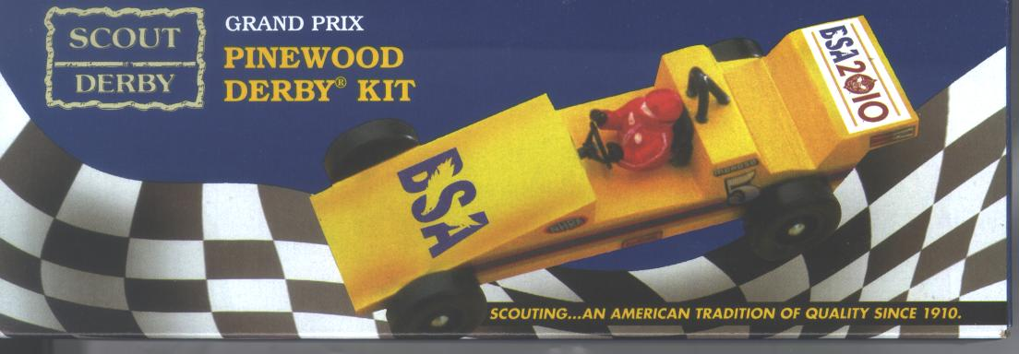

- Additional kits may be purchased from:
RYAN & SONS FAMILY SPORTS
15 North Main Street, Attleboro, MA 02703-2231
TEL: 508-222-3000 OR 508-222-3038

Or
Brenner’s Childrens Shop
694 Washington Street, Norwood, MA 02062
TEL: 781-762-2276

- Kits may be purchased elsewhere if they are of the exact type manufactured by the BSA as specified above.
- As mistakes are often made, spare parts will be available from the Pinewood Derby Race Commissioner if needed.

Competitor Categories
- DENS: Cub Scouts will compete in heats with all other Scouts. At the end of the heats, the Scouts will be ordered in the same Cub Scout RANK (Tigers, Wolves, Bears, Webelos) based upon average elapsed time ignoring each racer's worst time.
- PACK: The first four place winners overall will move on to the Pack Grand Finals and compete for the overall Pack positions of first, second, third and fourth place based upon average elapsed time ignoring each racer's worst time.

Attendance
The Cub Scout MUST register and race his own car. This means that the Cub Scout must be present at "Inspection and Registration" and the actual race to enter his car into competition. Exceptions to this rule may be granted by the Race Commissioner prior to the event. Although a scout’s car may be allowed to race if he has been granted an exception, the car will not be allowed to advance to the Grand Finals. Scheduling conflicts due to elective activities in which the boy must prioritize and choose ie, sports, parties, school events, stayed home to watch SpongeBob, will not be accepted as exceptions to this rule.

Scouts - New Work
- Construction of ALL Scout entries MUST have begun AFTER last year's Pack 116 Pinewood Derby Races.
- The car must be newly constructed each year.
- Modifications to previous year cars shall not be accepted.

Drivers Licensing, Car Registration and Inspection Date(s) and Time(s)
- Each Scout driver must pass an eye exam and written Pinewood Derby Driver exam. A score of 10 correct answers on the test of 10 questions signifies passing. A scout will be allowed to retake the test as many times as necessary.
- Each car must pass a technical inspection before it may compete.
- Technical inspection and registration of cars shall occur on the date(s) and time(s) called out in Section 8 APPENDIX A: Important Dates to Remember.
- The car drivers must and their parents/guardian should be at the registration and inspection in case the car is too heavy and weight must be removed or other modifications are necessary to pass the inspection. Exceptions to this rule may be granted by the Race Commissioner prior to the event.
- Single Entry per Person - Only one car may be registered by any person in the Pinewood Derby with the following exception. The Cub Master is allowed to race a car in the Scout Race (Cub Master’s Pace Car) and the Sibling & Adults race.

  - Late Registration and Inspection
- If a Cub Scout fails to register his car by the close of registration and late registration, he may be unable to race due to the commencement of race heat calculations. Those waiting in line at the close of registration will be allowed to register.
- Cars MAY NOT be registered after the close of registration. No exceptions. Please refer to Section 8 APPENDIX A: Important Dates to Remember for important dates and times.

Failure to Pass Inspection
- The Inspection Committee shall disqualify cars which do not meet the rules as described herein.
- If a car does not pass inspection, the owner will be informed of the reason his car did not pass.
- Cars which fail the initial inspection may be taken for modifications and brought back no later than the close of registration for final inspection and registration. Please refer to Section 8 APPENDIX A: Important Dates to Remember. for important dates and times.

Impound
- After a car passes inspection, it will be securely stored (impounded) by the Pinewood Derby Race Committee until race day/time.
- No car may be altered in any way after it has been registered and impounded.

Car Design Rules Interpretation
Interpretations of the rules described within this document are at the sole discretion of the Inspection Committee Judges present during the Registration and Inspection process.

Race-Day Rules Interpretation
- On Race-Day, the Cub Scout must make all questions of rules interpretations and procedures to the Pinewood Derby Race Commissioner or Race Officials promptly.
- Decisions of Race Officials on questions of rules interpretations and procedure may be appealed to the Pinewood Derby Race Commissioner.
- All decisions of the Pinewood Derby Race Commissioner are final.
- Decisions of Race Officials on questions of fact (i.e. the result of a specific race) may not be appealed beyond the Trackmaster and/or Finish Line Judges.
NOTE: Unsportsmanlike conduct by any participant or spectator will be grounds for expulsion from the competition and/or the race area.

CUB SCOUT RACE CAR DESIGN REGULATIONS

Overall Car Specifications
- Maximum Overall Width (outside edge-to-edge of wheels): - 2 3/4"
- Minimum Width between wheels - 1-3/4”
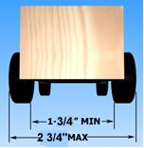
Figure 1 - Inside & Outside Wheel Specifications
- Wheelbase – The distance between axles can be changed as long as the wheels do not exceed the maximum length.
- Maximum Length - 7"
- Maximum Height – Not to exceed 3”
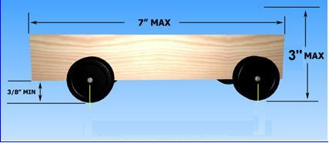
Figure 2 - Length, Height, Wheelbase, & Clearance Requirements
- Minimum Track Clearance - Bottom clearance between
car and track - 3/8"
NOTE: This clearance is to allow the car to go from the sloped portion of the track to the flat portion without dragging.
- Front of Car - No part of the car can extend beyond the starting post.
- Maximum Weight - Not over 5.00 Ounces

Material
- Race cars shall be constructed for this event from the parts contained in the Official Grand Prix Pinewood Derby Kit (referred to below as the kit) as distributed at the appropriate pack meeting.
- Materials from the kit may be supplemented but not replaced.
- "ADD-ONS" are not restricted as long as they meet with the rules and regulations as specified within this document.
- Special paint, decals, decorations, etc. are allowed.
- Unofficial kits will not be accepted. The “Pine Car” Pre-Cut Design bodies WILL NOT be allowed to enter the Race.
- Purchasing of completed cars is strictly prohibited and these cars will not be allowed to Race.

Weight
"Weight" is considered to be any material on the car that is not provided in the kit.
- Race cars may weigh no more than five (5.00) ounces total weight as determined on the official scales during the pre-race registration and inspection.
- Weight may be added to the car and will be considered part of the car for purposes of all measurements.
- The car may be hollowed out and built up to the maximum weight by the addition of solid materials such as wood or metal provided it is securely attached or built into the body chassis.
- All weight must be securely fastened to the car, e.g. by permanent glue, nails or screws, but not by "sticky substances", e.g. tape, or tack spray. The weight MUST NOT be taped on (i.e., masking tape, duct tape, scotch tape…). Heavy duty double back tape such as that used by the ones sold by the BSA - Stick-On Weights (WW7603) are not allowed.
- No liquid weights are permitted inside or attached to the outside of the car body. Weights shall be passive, i.e. non-moveable, non-magnetic, non-electric, non-sticky.
- Weight may be added or subtracted during the inspection process, but no weights may be added after the car has been registered, inspected and impounded for the race.
NOTE: The official scale will be available during the Pack Construction Clinics as well as during registration. Please refer to Section 8 APPENDIX A: Important Dates to Remember for important dates and times for the clinic
HINT: If you are unable to check the weight of your car on the official scale prior to registration, then it would be a good idea to be slightly under weight on any other scale you are using. (ie, Post Office) On registration day, it is easier to add weight than it is to remove excess weight by drilling holes in the bottom of the car.

Wheels and Axles
- All cars must have 4 (four) wheels attached from the official kit.
- The wheels shall turn about the axle nails from the official kit. It must be obvious to the judges that the wheels and the nails from the kit are being used.
- Only official BSA wheels and axles may be used as replacements.
- Hubcaps/wheel covers, washers, inserts, sleeves, bushing, or bearings are not allowed.
- The axle nails shall be firmly affixed to the wood of the car body. Axles may be modified or polished.
- Wheels may be modified or sanded to remove molding burrs as long as it is obvious to the judges that the wheels from the official kit are being used. To make it obvious to the judges, the words BSA, Pinewood Derby or the remnants of spokes must still be seen on the wheels. Only one of these conditions need to exist to be considered acceptable.

Size
- Race cars may be no longer than 7 inches, as determined by the official gages during the Registration and Inspection.
- Race cars may be no wider than 2-3/4 (2.75) inches, as determined by the official gages during the Registration and Inspection.
- Underside clearance of at least 3/8 (0.375) inches and inside wheel to wheel clearance of at least 1-3/4 (1.75) inches is recommended, so that the car will run on the race track.
- Adequate height clearance of 3” is the responsibility of the race car builder.

Lubricants
- The wheels and axles may be lubricated with DRY POWDERED LUBRICANT only. Absolutely no liquid lubricants will be allowed.
- Lubricants may not foul the track.
- There will be a lubrication table set up at the race in case wheel or axle repairs are necessary during the race. The replacement part may be re-lubricated under the supervision of a race official.
- Only one additional lubrication is allowed by the Scout only before the beginning of the Grand Pack Finals under the supervision of a race official.

Unacceptable Construction
- No loose material of any kind is permitted in or on the car.

Car Numbering & Name
- Each car will be identified with the number assigned at the time of distribution of the cars.
- The car's owner decides where to place the number, but he must place it so that it is visible from above (cars’ numbering cannot be on the bottom).
- If the car is not numbered correctly at the inspection, the inspector will mark the car appropriately with a permanent marker in an area designated by the participant.
- Each car will be required to have a name or description presented at the time of registration

Gravity Powered
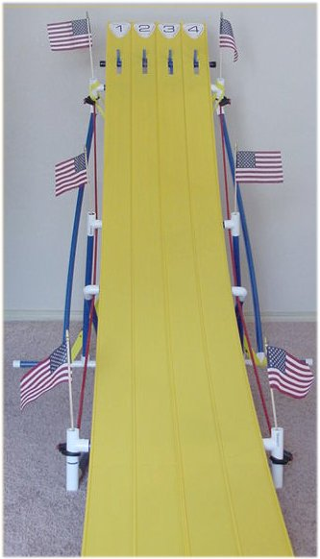
- The race car may not be constructed or treated in such a way that the track's starting mechanism imparts momentum to the car.
- Cars with sticky substances on the front of the car and protrusions which may catch on the starting pin shall be disqualified.
- The car shall not run on any type of springs.
- The car must be free-wheeling with no starting devices.
- Must be only Gravity Powered

THE RACING ENVIRONMENT
The Pack uses the commercially available “SuperTrack Pinewood Track”. Their web site is located at:
- http://www.SuperTimer.com/track/supertrack

Track Length and Drop
The track shall have a racing surface (starting line to finish line distance) of approximately 42 feet with a drop of approximately 4 feet.

Track Curve
The track section is flexed, rather than pre-bent into shape. This means that the track finds its own best curvature, and is not limited to the simple straight line and circular arc segments. The shape is actually properly referred to as an 'easement' or 'spiral curve'. You will find easements designed into highway off-ramps and curves on railroad tracks. Even in NASCAR you will find that the ”line” a driver takes around a turn is best described as a ”spiral curve”.

Lanes
The Packs’ Pinewood Derby Track has four (4) lanes. Each lane has 3.4 inches of clear wide surface and is edge guided. Because of the precision edge guides, the wheel's outside, more rounded surface is used to guide the car instead of the sharper inside surface, reducing lane jumping. Jumping is further reduced by the molded-in smoothness of the guides.
Starting Mechanism
http://www.newdirections.ws/startgate.htm
The cars start at rest against aluminum rods which are protruding through slots in the track. Remote tripping a small solenoid quickly rotates the pins beneath the track and releases the cars.
To start the races, all we do is aim a wireless remote control at the light tree and press the button. Better yet, give the remote control to one of the younger siblings in the audience, and make him or her the Official Race Starter!
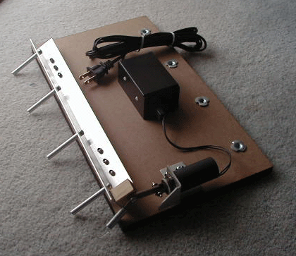 | 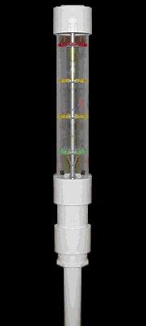 | 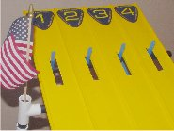 | 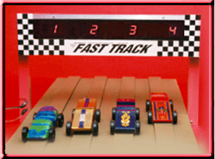
Starting Mechanism | Light Tree | Starting Gate | Finish Line Sensor

Finish Line Sensor Location
- The track has electronics called "finish line sensors" that shall be in alignment with the corresponding starting line pin and be approximately centered in its lane.
- Electronic finish lines use optical sensors to determine when a car crosses the finish line. However, there is one fundamental principle of electronic finish lines that must be understood. Electronic Finish lines select the finish order based on the sequence in which the light sensors are activated, not necessarily on the order in which the cars cross the finish line. See Figure below
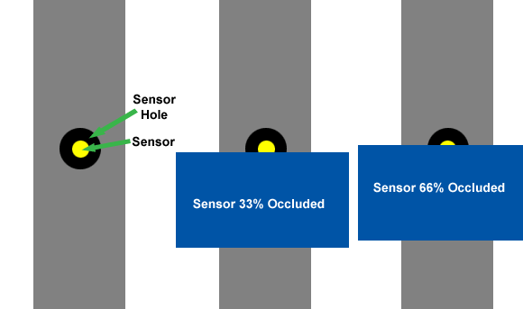
- For a car with a full-width (or reasonably wide) front end this deviation causes no issues at the finish line. However, cars with narrow noses can have problems with covering the sensors, See figure below
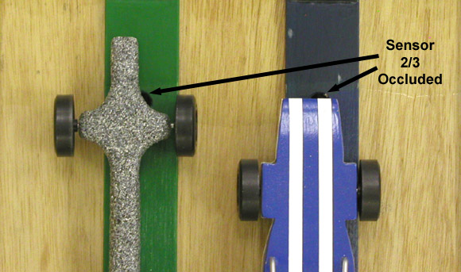
- The primary finish line sensors shall be connected to the computer system that will be managing the race. Placement and times shall be displayed by this system on a screen viewable to all participants.
- The Pack uses the “GrandPrix Race Manager” software available from Grand Prix Race Software. http://grandprix-software-central.com/gprm/download_gprm.htm version 8.0.

Finish Line Judging
- Two impartial Finish Line Judges shall be at the finish line to observe each heat on the track.
- Heat finish judging is determined by the finish line sensor, but may be challenged by a majority rule of the Finish Line Judges.
- If the track's electronic finish line sensor's result is challenged by the Finish Line Judges, the race will be re-staged and re-run. Finish Line Judges will temporarily recuse themselves if they know that one of the heat contestants is a son or relative.
- Backup Finish Line Judges shall be available in case a judge needs to be recused for any reason.

Car Brakes
The cars are prevented from running off the end of the track by means of a custom foam braking section called “Gasoline Alley” at the end of the track which stops the cars in individual tapered sections. This prevents each car from jumping out of its lane and slows the car over several inches.

RACE DAY RULES, REGULATIONS, AND INFORMATION
Competition will consist of entire Pack heat races with results given for each RANK, and a series of four Grand Final heats at the Pack level. Track officials are responsible for the proper conduct of the races.

Inspection Gages
- The race-day "Pit Stop" area will have the official scale and inspection box.
- The check-in equipment used during the Inspection and Registration of racers shall be the official equipment for the race.
- The same 5 oz. Master Weight used for scale calibration in pre-race check-in will also be available on race day.
NOTE: Please stress this fact to all Cub Scouts. They should be prepared to make adjustments to their cars if necessary.

Race Day Lubrication
In the interest of fairness, there will be a lubrication table set up at the race in case wheel or axle repairs are necessary during the race. The replacement part may be re-lubricated under the supervision of a race official.

Car Handling Responsibility
- Car Handlers shall be responsible for presenting the cars from the Derby Garage to the starting line for staging.
- Cars will be staged on the tracks by an adult or a senior member of the assisting Boy Scout Troop under supervision of the "Starter Team."

Lane Assignment
Lane assignments shall be determined by the racing software used to manage the race.

Car Leaves Lane
- If, during a race heat, a car leaves its lane but proceeds down the track in a manner that does not interfere with its opponent, then the race will be called normally.
- If the car leaves its lane and interferes with another car, the interfering racer will be given 2 minutes to inspect and/or repair the car with the assistance of his adult partner or Pit Crewmember, re-qualify if necessary and the race will be re-staged and re-run.
- If the same car again leaves it's lane and interferes with another car, that car will be judged with a 9.9999 second finish and the race will be re-staged and re-run without that car.

Car Leaves Track
- If, during a race heat, a car leaves the track without interfering with its opponent, the racer will be given 2 minutes to inspect and/or repair car with the assistance of his adult partner or Pit Crewmember, re-qualify if necessary and the race will be re-staged and re-run.
- If the same car again leaves the track, that car will be judged with a 9.9999 second finish and the race will be re-staged and re-run without that car.

Car Repair (Without Fault)
- If, during the race, a wheel falls off or the car becomes otherwise damaged, then the Scout may, to the best of his ability perform repairs with the assistance of his adult partner or Pit Crewmember.
- The Racer and Pit Crew shall be allowed 5 minutes to perform repairs with the assistance of his adult partner or Pit Crewmember and re-qualify for racing. This time may be extended upon the approval of the Trackmaster.
- The car shall be re-qualified for racing in accordance with the Rules above.

Car Repair (With Fault)
- If a car is damaged due to track fault, or damage caused by another car or person, then the Trackmaster, at his sole discretion, may allow additional repair assistance and time to the Cub.
- The car shall be re-qualified for racing in accordance with the Rules above.

Track Fault
If a car leaves its lane, at his sole discretion, the Trackmaster may inspect the track and, if a track fault is found which probably caused the initial violation, the Trackmaster may order the race heat to be rerun after the track is repaired.

Call to Race
- Competitors will be called by their Car Number and Name prior to each heat.
- When the Car Number is called an adult will retrieve the car from "the garage" and present the car to the Starting Team.

  - Track Champion
- The four Scouts and their cars with the fastest average times ignoring each racer's worst time, shall be accompanied from the track to the stage by his parent or other designee.
- Inspection, repair as necessary and addition of lubrication, all performed solely by the Cub Scout, will be permitted prior to the start of the Grand Final Heats.
- The cars will be impounded on the stage until the start of the Grand Final Heats.
- Trophies will be awarded for the 1st, 2nd, 3rd and 4th place scouts in this Grand Final Heat

  - Team Champions
- A large team trophy, bought just once (perhaps sponsored with gifts) will annually be presented to the most consistent team. (Fastest average time minus slowest average time within rank). This trophy will be as important or more important than the overall winner. The presentation of the Team Trophy will be a major ceremony after presentation of the individual awards. The teams’ Den and year will be engraved on the Trophy.

The Race Area
Only Race Officials may enter the track area. This rule will be strictly enforced.

Rewards and Recognition
The most important values in Pinewood Derby competition are parent (guardian)/son participation, good sportsmanship and learning how to follow rules.
The Awards Committee is responsible for recognizing and encouraging these qualities in addition to traditional racing awards.
Racers will be recognized as follows:
- Every participating Scout will receive a Pinewood Derby Patch or Pin.
- Pinewood Derby trophies will be given to the First, Second,Third etc, up to the Tenth place finishers for fastest average time ignoring each racer's worst time in each Den.
- Every Scout car which does not place in the top ten for speed will be awarded a certificate/trophy for winning its own unique appearance category (Most Creative, Most Humorous, Most Colorful, Best Paint Job, and so on) see Appendix 11 for list.
- Awards will be given for the First, Second, Third and fourth place finishers for average fastest time ignoring each racer's worst time overall in the Pack after the results of the Grand Final Heat are known.

PARENT'S & SIBLINGS CAR DESIGN RULES & REGULATIONS
(... or "Why should the kids have ALL the fun?")
The purpose of the Parents & Siblings Race event is to have a little fun and to test our Pinewood Derby track. It will also help us to 'bleed' off some of our nervous competitive anxiety …
All adults and siblings are encouraged to build their own cars. The adults/siblings race will be held prior to the Cub Scout race. Any sibling, parent, grandparent or guardian of a Cub Scout who is registered in the Pack may enter this race.

Technical standards
The Technical Standards for the Cub Scout race (above) will be used in the Parents Race.
Other than this, your car must meet regulation Height, Width, and Length or it may not fit on the track!!!!

The Car
You may NOT use your son's current car for this race.

Weigh-In / Race Registration
Same Date & Time as Cub Scouts.

What Do The Winners Get?
All Adult/siblings that participate will be awarded Pinewood Derby ribbons.
Adult/sibling winners will be recognized and be presented with large ribbons which signify 1st, 2nd, 3rd and 4th Place.

Who’s a Winner?
Everybody who has fun racing and helps others to have fun is a WINNER!!!

APPENDIX A: Important Dates to Remember
DATE | TIME | LOCATION | DESCRIPTION | COMMENTS
10/09/09  Friday | 6:30pm | Chapel Meeting House | Down and Derby Movie | Pinewood Derby History, Pinewood Derby ABC’s
11/15/09  Sunday | 4pm | American Legion Hall | Pinewood Derby Kits Distributed | Surprise Guest Delivery
12/05/09  Saturday | 9:00 to 12:00am | Camp St. Augustine, Rec Hall | Pinewood Derby Clinic #1 Car Design and Rough Cut Outs | BRING YOUR CARS!!!
1/02/10  Saturday | 9:00 to 12:00am | Camp St. Augustine, Rec Hall | Pinewood Derby Clinic #2 - Car Finishing | BRING YOUR CARS!!!
1/14/10  Thursday | 6:00 to 8:00pm | Taylor School  Cafe | DPV (Department of Pinewood Vehicles) Registration and Driver Licensing | BRING YOUR CARS!!!
1/15/10  Friday | 5:30-6:00 pm | Taylor School  Gym | LATE DPV (Department of Pinewood Vehicles) Registration  (No Driver Licensing) | BRING YOUR CARS!!!
1/15/10  Friday | 6:00-9:30 pm | Taylor School  Gym | Pinewood Derby Race Day! | BRING YOUR CARS!!!

APPENDIX B: The Race Committee, Volunteers, & Officials
A successful and fun Pinewood Derby is highly dependent on the work of the "Pinewood Derby Committee, Volunteers, and Officials."

Committee Roles & Responsibilities

Race Commissioner – Michael Gawronski 508-922-0243
This individual is responsible for all coordination activities and the Race Committee. Strong organizational, motivational, and leadership skills are required here. The Race Commissioner will typically host a number of meetings in the months prior to the Derby to collect and coordinate the status of all of the other Committee members, and to assign/coordinate additional tasks. During the races, the Race Commissioner will also act as the behind the scenes coordinator of the event, coordinating solutions to all unforeseen 'emergencies' should (when) they arise.

Master of Ceremonies
The MC is the Committee 'mouth' during the Derby. He / she announces all races and racers, all results, and all other general communications during the event. The MC also presents all trophies, certificates, and medals to event winners during and after the Derby. Your Cubmaster is a good bet for the Master of Ceremonies.

Rules Committee
The Rules Committee is responsible for the creation, approval, and distribution of the ‘Rules, Regulations, and Procedures’. The Rules Committee can consist of all interested Pinewood Derby Committee members. Key players in the process are the Race Commissioner, the Registration Team, and the Trackmaster Team, even though all committee members can participate.

Sponsors Team
The Sponsors Team is responsible to locate local businesses and organizations that will contribute decoration items, 'giveaways,' and raffle goodies. If we plan to make a profit from the race, a Unit Money-earning Application form (BSA A-136) must be filled out by the Pack, and approved by the Council prior to accepting donations of 'goods' from local businesses.

Construction Clinic Team
A team of individuals that understands woodworking, tool safety, and Derby car construction techniques. This team will be responsible for the planning and running of the Pack Derby Construction Clinics. Someone on this team should have the ability to communicate in front of the pack and review the Rules and Regulations as well as Constructions Tips and Tricks. The team should be ready to answer a lot of questions and offer one-on-one assistance to first time builders.

Pit Crew Team
A team of individuals that comes together during the race to assist with any car repairs that might be necessary should cars 'fly' off of the track, or get dropped, etc. Construction Clinic Team members may participate here as well.

Trackmaster Team
This team is responsible for the Track Setup and Repair. This team assembles the track and timers in the weeks before the race, and effects any repairs that might be necessary. During the races the Trackmasters are also responsible for keeping the track fast and race running smoothly.

Registration Team
We typically require that cars be turned in for impound before the Pinewood Derby. This occurs one day prior to the event. There will be a number of individuals responsible for check-in, weighing, and conformance to our rules on duty during this period. These individuals MUST be very familiar with the car construction rules. This can be a 'tough' job!

Starting Team
Two to three individuals that are responsible for staging and starting cars. These individuals shall assist in the placement of the cars on the track. They shall make sure that the cars are in their proper lanes for the races and also properly placed.

Decorations Team
These individuals are responsible for all Derby decorations during the Registration and Race. This involves decoration acquisition from purchased sources, and locating businesses that are willing to donate decorations.

Finish Line Team
Two to three persons per track are responsible for working the finish-line during the races. This job involves judging car finish order (as a backup for the electronic timers) and handing the cars to the appropriate handler upon completion of the race.

Refreshments Team
This team individuals are responsible for the purchase and set-up of snacks during the event. Typically, the Pack should take in slightly more funds than their refreshments outlay.

Crowd Control / Cub Escorts
Our Den Leaders are each responsible for helping their Cubs with race day logistics (and behavior.) They also help with some of the more difficult lessons that Cubs learn about 'sportsmanship' during the races. Typically Boy Scout Volunteers from Troop 32 will assist with crowd control around the track and staging areas.

Race Management Team
The Race management Team is responsible for the planning and management of the race. This includes the planning of the various racing heats, the collecting of race outcomes, and the calculation of the race winners and Grand Final Race participants. This is typically accomplished using a Race Management Software package.

Awards Team
The awards team is responsible for developing an award program for the races, and moving it through an approval process by the Cubmaster and Committee Chair. The awards person then purchases trophies and medals, and coordinates the making of certificates. We award trophies for the 4 fastest cars, pins for first thru third place in each Den, and really nice personalized certificates, pins, patches, etc. for all participants.

Cleanup Team
All of our Committee members (and maybe some volunteer parents) help with post-event cleanup.

APPENDIX C: The Science of the Race and Construction Tips
The purpose of this section of the document is to offer you a better understanding of the science involved in the race as well as a few tips along the way. The information we are presenting here has been gathered from numerous articles and websites over the years. As this information is neither proprietary nor patentable and is available to the public in many forms from text books to the internet it would be impossible to list all the sources from which you might be able to gather the information.

The Goal of The Race
Get from the Starting Line to the Finishing Line as fast as possible!!!
This may seem to many to be very obvious, but you would be surprised that many feel that it’s to make the coolest fastest looking and most aerodynamic looking car than anyone else. The thinking here is that if you can do this, than obviously you will win the race. Right? Well no, not quite right… We have held many races over the years and you would be surprised as to how many times a Cub Scout shows up to the race, pulls the block of wood out of the box, puts on the wheels and wins the race.
You may ask, “How can this be?” Read on a little about the Science involved and a few of the tips and tricks and you will see.

What Makes My Car Go?
Hmm, most racing cars use a special blend of racing high octane fuel. What do you think fuels our cars? Rockets, Springs, Rubber Bands, a good push from a Scout…. Nope not any of these….. OK it’s GRAVITY!
This is why all of the races start up high on a sloped portion of track. Gravity pulls on our cars at a rate of 32 feet per second per second. Once the starting line is dropped, gravity literally pulls the car down the sloped portion of the track. OK, so now we know Gravity fuels our cars. But guess what, you run out of this fuel as soon as the car hits the flat level straight section of the track!
Now back to more scientific stuff… Gravity imparts a “Force” that moves the car. The formula that applies here would be F=ma or Force=mass X acceleration. Alright we have more technical words to explain here. What is Mass? Mass is defined as a property of matter equal to the measure of an object's resistance to changes in either the speed or direction of its motion. The mass of an object is not dependent on gravity and therefore is different from but proportional to its weight. The key here is that the mass of your racing car “is proportional to its weight.” Acceleration is defined as the rate of change of velocity with respect to time. Here, you remember that we spoke of 32 feet per second per second.
Now if it was only that easy. We actually have two forces of Gravity working on our cars. The force that is pulling the car “along” the track and the force that pulling the car down onto the track. These two forces are part of what is referred to as the car’s gravity force vectors.
OK, so now we know that Gravity is the fuel, but where or how does our car store this fuel? Gravity provides us with the fuel we need to store “Energy” up for the race while we are behind the starting gate waiting for it to drop. The amount of Energy our car stores up is equal to the mass of our car times the height it is from the level section of the track. The formula E=mh describes how much energy our car will be able to store up for the race. When the car is behind the starting gate waiting for the race to start it has stored “potential” energy. When the car is moving down the track it has “kinetic” energy. When the starting gate is dropped, the potential energy is transformed into kinetic energy.
So now we know what makes our car go. You should also know that this is what makes all our cars go. So why aren’t all the races ending in a tie? Ahh, to understand this we need to look at what makes our cars SLOW… or STOP…

What Makes My Car Slow?
The bad guy here is FRICTION! Friction is the main force (there’s that word again) that slows our car. Friction is defined as a force that resists the relative motion or tendency to such motion of two bodies in contact. Our cars wheels and the track are the two bodies that are in contact here. OK, yes, air is also in contact and some may say that reducing this contact by building the most aerodynamic high polished car would reduce this “air” friction. Bah-humbug is about all I can say to this. I have read a number of articles and the vast majority say that if all of your race cars are of equal weight of 5 oz. and at the size these cars are, air friction is negligible. Remember the block of wood out of the box that won the race!
Friction turns our energy into heat rather than the motion we need down the track. So now we know that Gravity fuels our car and we store it up as “Potential Energy” before the race and transform it into “Kinetic Energy” as the race starts. We also know that Friction is the main culprit that slows our “motion” down the track and waists our energy by turning it into heat instead of motion.

The Fuel
Let’s look at the “Fuel” side of the race first.
We first talked about Gravity and we can’t do much about it. If anyone knows how to increase the force of Gravity, let alone on only their car and not the others, please let us know. There has to be a Nobel Prize in it somewhere.

Weight – How Much?
So if not Gravity, we can only affect the “Mass” of our car. In all my research, the agreement here is to make your car as heavy as the rules and regulations allow. Typically this is 5.00 ounces. So go out, grab some lead and glue it on and your done… right…ahh if it was only that simple.

The Friction
The second area we need to discuss is what makes our car slow - Friction. How can we minimize friction? What ever you do, remember to follow the Rules and Regulations of our organizations’ race and always ask questions to your officials prior to race day. It sure would be sad to show up with what you think is a cool idea to take advantage of what you think is a loophole in the regulations and have your car disqualified. Remember, the Rules and Regulations of most organizations are left to the interpretation and final judgment of the Race Officials and Race Commissioner. Just because you may not have explicitly read something in the rules, the Race Officials are free to extrapolate rules that may affect your design. A good example would be the use of a plastic sleeve on your axle that makes sure that the wheel does not rub on the car. You could argue to your blue in the face that this is not a “washer,” but you will lose the argument. If you have a question, contact your officials.
So Friction is our challenge to overcome and wheels rubbing on or touching things are the cause. We want our wheels to spin as freely on the axles as possible, not to rub on the car or the track’s guide rails
Some may insist that “aerodynamics” plays a part in winning. However, we have seen the best built, most aerodynamic car come in last while the plain block of wood straight out of the box come in first!

Lubrication
There is only one (1) type of Lubrication that is allowed:
- DRY POWDERED
Research on the web has shown this to be the lubrication of choice. Pre-lubricate axles and wheels using, dry powdered lubricant. Do not use regular oil or silicone spray, since it may soften the plastic wheels.

Lubrication Application
First you need to remember, as all good scouts should, to “Be Prepared.” Be prepared to make a big mess. Be prepared to control the mess and you will be able to cut down on cleanup time.
First cover all surfaces with paper or plastic. Once the lubrication has been applied, you will be able to carefully fold the covering onto itself and toss it in the trash. Second, make sure you have plenty of “Zip-Lock” bags. Third, you should also have a roll or two of paper towels around so you can try and control the mess on the paper towel and then throw it away when you are done.

Wheel Preparation
Again, remember to follow the rules of our Pack. You might consider modifying or polishing the wheels surface. However, be careful not to remove all the BSA, Pinewood Derby or spoke pattern on the side as this would disqualify the car. You will want to make sure there are no burrs and/or irregularities in the plastic that would keep the wheel from spinning freely or cause it to wobble on the axle.

Painting And Wheel Assembly
Apply several coats of sanding sealer; then sand your entire car with a fine-grade sandpaper.
Give car at least two coats of fast drying paint, in your choice of color.
When paint is completely dry sand with a fine sandpaper, apply a final coat of paint and allow to dry thoroughly.
TO FINISH, rub entire car with a rubbing compound.
Details such as windshield, driver, racing numbers, etc., should be added now.
For a super finish apply a coat of auto wax and rub to a high gloss.
Slide wheels over axles, then gently tap them into the car body grooves with a 1/4" dowel or similar object to within 1/32" of car body. Make sure wheels turn freely.

Closing Comments
Your set, go out and HAVE FUN and you’re guaranteed to be a WINNER! Remember, it’s not the winning that’s important in this race. It’s spending time with your boy, teaching him a few skills, building the car together, learning and following the rules, having fun, and on race day helping others to have as much fun as possible! If we all have fun then we are ALL WINNERS!!

APPENDIX D: Workmanship, Originality, and Creativity Awards
In contrast to awards for speed, which obviously are made based solely on quantitative performance, awards for workmanship, originality and creativity, will be based on qualitative factors of the actual cars presented, solely at the discretion of the judges. Since the whole point of these awards shall be to recognize the children's creativity and craftsmanship, there are no preset criteria for the workmanship and originality awards. But some of the factors the judges may consider and recognize include:
Best Paint Job | Smoothest Finish | Most Unusual Car
Most Colorful Paint Job | Strangest Shape | Fastest Looking Car
Shiniest Paint Job | Most Futuristic | Most Decals
Best Use Of Color | Most Patriotic | Best Block of Wood
Most Realistic | Funniest | Smoothest Finish
Most Realistic Looking Car | Best Wedge Shape | Sportiest
Most Original Design | Best Driver In the Car | Most Creative Use of Material
Coolest Design | Best Vehicle Not A Car | Best Fuel Economy (slowest car)
Best Funny Car | Best Racer
Most Unusual | Best Design
Sportiest Looking | Most Unique
Best Workmanship | Judge's Favorite
Best Use of Imagination | Best of Show
Most Aerodynamic Car | Most Creative
Best Detail | Most Artistic
The intent in offering just as many awards for workmanship and originality as for speed is to remind both Cubs and parents that there are many different paths to success in life. Not everyone has to run and compete in exactly the same race to be a success. Each child is unique. What we do hope our Cubs will learn is that what's really important is just what's in the Cub Scout Motto: Do your best!

APPENDIX E: Gilbert and the Pinewood Derby - A Simple Prayer
by Peggy Porter
My son Gilbert was eight years old and had been in Cub Scouts only a short time. During one of his meetings he was handed a sheet of paper, a block of wood and four tires and told to return home and give all to "dad."
That was not an easy task for Gilbert to do. Dad was not receptive to doing things with his son. But Gilbert tried. Dad read the paper and scoffed at the idea of making a pinewood derby car with his young, eager son. The block of wood remained untouched as the weeks passed. Finally, mom stepped in to see if I could figure this all out. The project began. Having no carpentry skills, I decided it would be best if I simply read the directions and let Gilbert do the work. And he did. I read aloud the measurements, the rules of what we could do and what we couldn't do.
Within days his block of wood was turning into a pinewood derby car. A little lopsided, but looking great (at least through the eyes of mom). Gilbert had not seen any of the other kids’ cars and was feeling pretty proud of his "Blue Lightning," the pride that comes with knowing you did something on your own.
Then the big night came. With his blue pinewood derby in his hand and pride in his heart we headed to the big race. Once there my little one's pride turned to humility. Gilbert's car was obviously the only car made entirely on his own. All the other cars were a father-son partnership, with cool paint jobs and sleek body styles made for speed.
A few of the boys giggled as they looked at Gilbert's, lopsided, wobbly, unattractive vehicle. To add to the humiliation Gilbert was the only boy without a man at his side. A couple of the boys who were from single parent homes at least had an uncle or grandfather by their side, Gilbert had "mom."
As the race began it was done in elimination fashion. You kept racing as long as you were the winner. One by one the cars raced down the finely sanded ramp. Finally it was between Gilbert and the sleekest, fastest looking car there. As the last race was about to begin, my wide eyed, shy eight year old ask if they could stop the race for a minute, because he wanted to pray. The race stopped.
Gilbert hit his knees clutching his funny looking block of wood between his hands. With a wrinkled brow he set to converse with his Father. He prayed in earnest for a very long minute and a half. Then he stood, smile on his face and announced, 'Okay, I am ready."
As the crowd cheered, a boy named Tommy stood with his father as their car sped down the ramp. Gilbert stood with his Father within his heart and watched his block of wood wobble down the ramp with surprisingly great speed and rushed over the finish line a fraction of a second before Tommy's car.
Gilbert leaped into the air with a loud "Thank you" as the crowd roared in approval. The Cub Master came up to Gilbert with microphone in hand and asked the obvious question, "So you prayed to win, huh, Gilbert?"
To which my young son answered, "Oh, no sir. That wouldn't be fair to ask God to help you beat someone else. I just asked Him to make it so I don't cry when I lose."
Children seem to have a wisdom far beyond us. Gilbert didn't ask God to win the race, he didn't ask God to fix the out come, Gilbert asked God to give him strength in the outcome. When Gilbert first saw the other cars he didn't cry out to God, "No fair, they had a fathers’ help."
Gilbert's simple prayer spoke volumes to those present that night. He never doubted that God would indeed answer his request. He didn't pray to win, thus hurt someone else, he prayed that God supply the grace to lose with dignity. Gilbert, by his stopping the race to speak to his Father also showed the crowd that he wasn't there without a "dad," but His Father was most definitely there with him. Yes, Gilbert walked away a winner that night, with his Father at his side.

